Suffolk Street Public Realm Improvement Scheme
Pre-Design Consultation Report
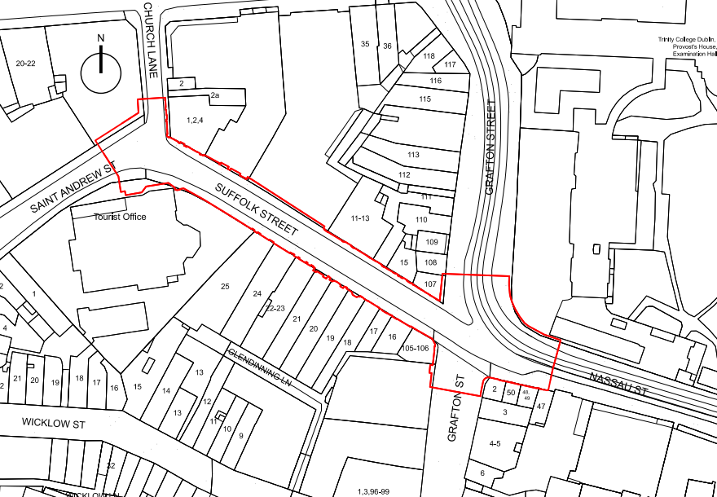



Contents

1)Overview 1
2)Engagement with DPOs 3
2.1 DPO Consultation 3
2.2 DPO Consultation Responses 3
3) Engagement with Local Businesses and Residents 6
3.1 Information Session for Businesses 6
3.2 Information Session response from Businesses 8
Question 1 responses 9
Question 2 Responses 11
Question 3 responses 13
4) Engagement with Public 16
4.1. Online Survey on 'Engage'……………………………………………………………………..16
4.2. Survey Responses 17
5) Next Steps 25

1)Overview
In 2026 Dublin City Council (DCC) commenced the early design phase of the Suffolk Street Public Realm Improvement Scheme, a project aimed at enhancing the quality, accessibility and functionality of this important area. Building upon the positive outcomes of the Covid-19 Mobility Measures introduced in 2021, the scheme seeks to create a more welcoming, accessible and vibrant public realm that supports the social, cultural and economic vitality of the city centre. The project is being developed by an in-house team from the Road Design and City Architects divisions, with assistance from the Traffic and Parks divisions.
Located in the historic core of Dublin, Suffolk Street serves as a key pedestrian route linking major destinations and attractions. The proposed improvements aim to prioritise pedestrian movement, improve universal accessibility, support active travel, increase greening and public seating opportunities, and create a high-quality public space that is attractive, safe and inclusive for all users. The project will also address essential infrastructure requirements, including drainage and utility upgrades, while ensuring continued access for emergency services and servicing requirements.
With a view to reimagining Suffolk Street as a dynamic and inviting public space for all, the Project Team actively engaged with key stakeholders during this initial pre-design phase to gather insights into their experiences of the current space, the challenges they face, and their aspirations for the future of the street. The pre-design stage of the project included an integrated and comprehensive engagement programme focused on gathering feedback from businesses, the public, Disabled Persons' Organisations (DPOs), and internal stakeholders within Dublin City Council.
The pre-design consultation process was undertaken between June and August 2026 and incorporated a range of engagement activities designed to facilitate meaningful participation and obtain local knowledge and expert insight. Stakeholder engagement during this phase included several key consultation touchpoints which enabled the DCC Project Team and the Integrated Design Team to engage directly with stakeholders and receive both verbal and written feedback.
The principal engagement activities comprised:
- An In-Person Information Session for Local Businesses and Stakeholders, held on 30 June 2025, which provided an opportunity for participants to discuss their experiences of Suffolk Street, identify existing challenges and opportunities, and share aspirations for future public realm improvements.
- DPO Consultation (Disabled Persons’ Organisations), which engaged directly with DPO representatives to better understand accessibility requirements, barriers experienced within the existing street environment, and opportunities to improve inclusivity and universal access as part of the scheme.
- An Online Consultation via Engage.ie, which provided members of the public and interested stakeholders with an opportunity to review project information and submit feedback on the future development of Suffolk Street.
Feedback received throughout pre-design stage focused on a range of themes, including pedestrian movement, accessibility, outdoor dining, cycling, greening, public seating, servicing arrangements, safety, and the overall character and identity of the street. The insights gathered have provided valuable local, community and stakeholder perspectives that will help inform the ongoing development of the scheme.
The following report outlines the key consultation activities undertaken during this pre-design stage, summarises the principal themes and issues raised by stakeholders, and identifies the opportunities and challenges highlighted throughout the engagement process. It also describes how the feedback received will be used by the DCC Project Team as the Suffolk Street Public Realm Improvement Scheme progresses into the next phase of design development. The findings presented in this report represent an important element of the wider consultation process and will be considered alongside future stakeholder engagement activities and subsequent statutory planning procedures.
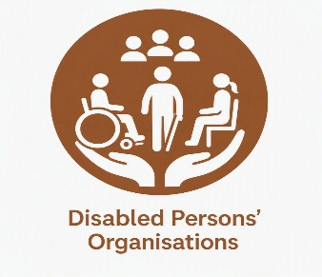

2)Engagement with DPOs
2.1 DPO Consultation
As part of the early engagement process for the Suffolk Street Public Realm Improvement Scheme, Dublin City Council (DCC) undertook pre-design consultation with Disabled Persons Organisations (DPOs) and accessibility representatives to better understand the experiences, accessibility requirements and priorities of people with disabilities using the existing street environment.
The DCC Project Team issued invitations by email to all Disability Persons Organisations (DPOs), inviting their representatives to participate in the consultation process; three DPOs responded to say they would like to take part.
The project team held an in-person meeting with representatives of ‘Dublin DPOs’ at DCC’s Wood Quay offices, where the project team provided a PowerPoint presentation supported by maps and information on the existing street environment and the proposed public realm improvement scheme. Separate site walks were also conducted with ‘Headway – National Advocacy Group’ and ‘Voice of Vision Impairment’ (VVI) along Suffolk Street and the surrounding area. These site walks provided an opportunity to assess existing street conditions and discuss accessibility issues and user experiences within the project area.
The consultations provided an opportunity to identify existing barriers to accessibility, discuss positive aspects of the current street environment and highlight opportunities for improvement as part of the proposed scheme. The discussions and site observations focused primarily on clear and continuous pedestrian routes, adequate footpath width, pedestrian and cyclist segregation, pavement condition and level changes, kerbs and pedestrian crossings, gradients, wayfinding and navigation, street furniture and other obstructions, outdoor dining, drainage, surface materials, and the overall safety and accessibility of the public realm.
The feedback received through the three DPO consultations has been reviewed collectively, with common and recurring issues consolidated to identify the key accessibility considerations to be taken forward during the development of the preliminary design.
2.2 DPO Consultation Feedback
The DPO consultations highlighted the importance of delivering an inclusive, accessible and safe public realm on Suffolk Street that prioritises the needs of people with disabilities and other vulnerable pedestrians. Representatives emphasised that the proposed design should provide a clear, continuous and unobstructed pedestrian environment that can be comfortably and independently used by wheelchair users, people with visual impairments, people with mobility difficulties, older people and parents/carers with prams.
A key concern raised was the interaction between pedestrians and cyclists. A lack of clearly defined areas and physical separation was identified as a significant safety issue, particularly for wheelchair users and visually impaired pedestrians. Cyclists moving through pedestrian areas, including e-bikes and other larger bicycles, can create uncertainty, near misses and intimidation. The DPOs requested clear and, where appropriate, physical segregation between pedestrian and cycling movements, with intuitive layouts and consistent cues that reduce the potential for conflicts.
The continuity and effective width of footpaths was considered particularly important. Footpaths should provide sufficient space for people to pass comfortably and should not be narrowed by street furniture, cycle parking, outdoor dining, advertising boards, planters, poles, bollards, bicycles or other temporary or permanent obstructions. Outdoor dining areas should be carefully located and designed to avoid conflicts between pedestrians and waiting staff, with a preference for arrangements that do not require people to cross the main pedestrian route.
The consultations identified uneven, undulating and poorly maintained surfaces as significant accessibility barriers. Damaged paving, changes in level, drainage channels, rough cobbles, poorly reinstated surfaces, cellar covers and projecting elements can create trip hazards, discomfort and difficulties for wheelchair and rollator users. Paving and other surface materials should therefore provide a smooth, even and slip-resistant surface, with appropriate gradients and well-designed drainage. Materials and details should also be selected and maintained to minimise hazards for long-cane users.
Wayfinding and navigation for people with visual impairments was another recurring theme. A continuous and detectable edge, such as an appropriately designed kerb, raised planting edge or consistent building line, can provide an important navigation cue. Excessively wide or open spaces can also be difficult to navigate without clear guidance. The use of consistent and intuitive design features, appropriate tactile paving, suitable visual and colour contrast, and identifiable anchor points should therefore be considered throughout the scheme. It was also noted that audible pedestrian crossing facilities should be appropriately located, maintained and sufficiently detectable.
Particular attention should be given to kerb design and pedestrian crossings. While kerbs can provide useful wayfinding information for visually impaired people, excessive or poorly designed level changes can create difficulties for wheelchair users and people with mobility impairments. The feedback indicated that the design should balance the need for a detectable continuous edge with the requirement for accessible crossing points. Additional pedestrian crossing opportunities should be considered along the length of the street, particularly where existing crossing provision is limited, and crossing arrangements should provide appropriate dropped or raised facilities and tactile information.
The location and design of street furniture and planting should be carefully considered to avoid creating hazards or reducing pedestrian space. Bollards, planters, bicycle parking, bins, poles, advertising structures and other features can present difficulties for people using long canes or mobility aids. Furniture should have appropriate forms, locations and detectable edges, with features extending to ground level where necessary to reduce the risk of cane snagging. Sharp corners and poorly positioned elements should be avoided. Planting and tree canopies should also be reviewed to ensure that they do not obstruct pedestrian movement, lighting or visibility.
The DPO feedback also highlighted the importance of appropriate materials, contrast and maintenance. Footpath, cycle track and carriageway surfaces should be visually distinguishable, while paving materials should provide good slip and skid resistance, including in wet conditions. The finished public realm should have a coherent and appropriate appearance that reflects the historic character of the area while remaining practical to clean and maintain. Ongoing maintenance of paving, tactile surfaces, drainage and other accessibility features will be important to ensure that the benefits of the proposed design are retained over time.
Overall, the DPO consultations emphasised that the scheme should adopt a simple, consistent and intuitive approach to accessibility, with the needs of vulnerable pedestrians considered at every stage of the design. The design should anticipate potential conflicts and hazards rather than relying on users behaving appropriately. The objective should be to create a street environment that feels safe, legible and comfortable for all users, enabling people with disabilities to navigate and use Suffolk Street independently and with confidence.

3) Engagement with Local Businesses and Residents
3.1 Information Session
As part of the early design stage of the Suffolk Street Public Realm Improvement Project, Dublin City Council hosted an Information Session in O’Neill’s Bar, on 30 June 2025, from 11:00 am to 12:30pm, to engage with local businesses and stakeholders and gather their views on the existing street environment and aspirations for its future development. All local Councillors were also invited to this session.
The session was attended by 16 participants and was conducted as an informal drop-in event. Display boards, maps of the proposed project area and three consultation questions were provided to support discussion and enable participants to record their views and feedback.
Participants were invited to share their experiences of the existing arrangements on Suffolk Street, identify current challenges and opportunities, and provide suggestions for the future public realm. The feedback received covered a range of themes, including outdoor dining, pedestrian movement, cycling, greening, public seating, accessibility, servicing arrangements and the overall character of the street.
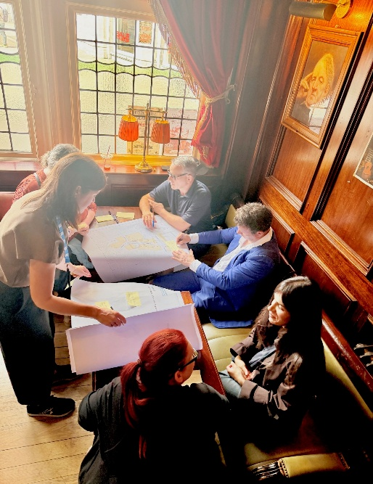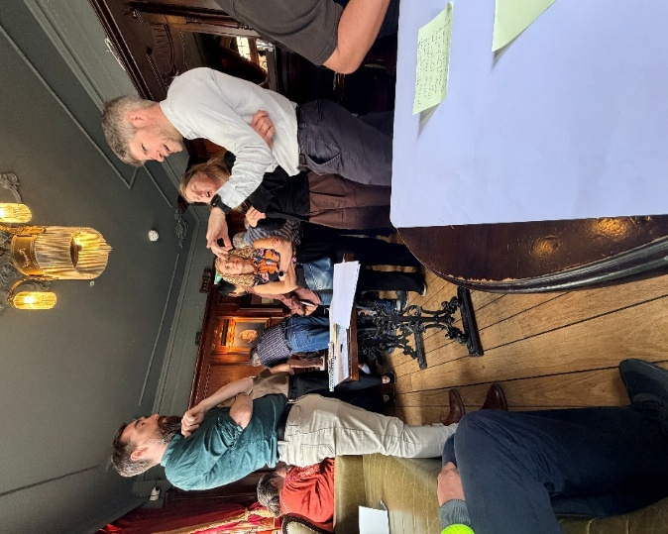
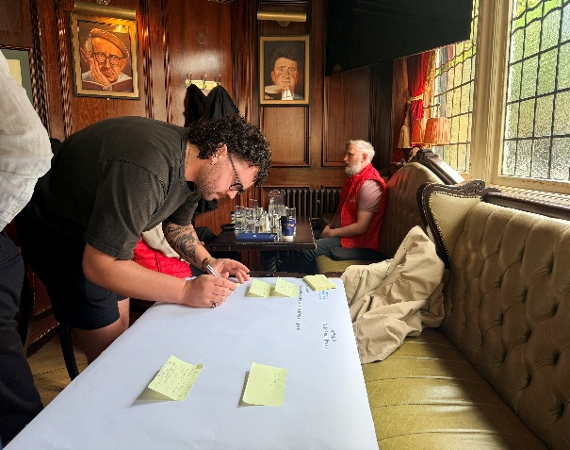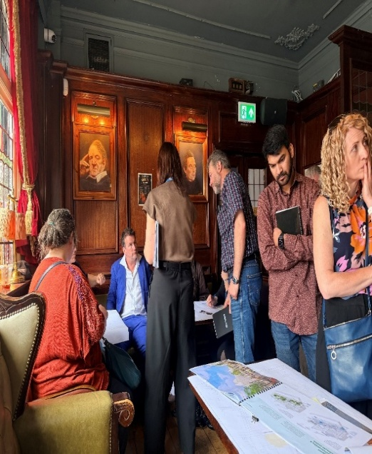
Figure 3.1: Photos from Information Session

3.2 Information Session Feedback

The Information Session sought to gather feedback from local businesses and stakeholders on their experience of the existing street, opportunities for improvement, and priorities for the proposed public realm scheme. Participants were asked three questions to focus the discussion, and were invited to provide written comments directly on the consultation boards, outlining their views and suggestions for the proposed improvements.

Figure 3.2: Participant Composition
Question 1
What are the current challenges with the existing space, and what works well?
Responses:
Challenges | What Works Well
Drug use and anti-social behaviour, particularly around the Molly Malone statue, negatively affect the quality and perception of the space. | The street is vibrant and attracts a high level of activity, with outdoor dining contributing to a lively and welcoming atmosphere.
Buskers can be excessively loud, with noise carrying along the length of the street. | Street activity and entertainment contribute to the character and vibrancy of the area when appropriately managed.
Pedestrian spaces are not clearly defined, resulting in conflicts between pedestrians and cyclists. | The pedestrianised environment encourages walking and supports outdoor dining and street activity.
Private outdoor dining structures occupy a significant proportion of the public realm, reducing pedestrian permeability. | Outdoor dining has been highly successful, supporting businesses, increasing customer activity, and enhancing the overall vibrancy of the street.
Maintaining efficient access for morning deliveries remains a challenge. | The current street layout continues to accommodate business operations, including servicing and deliveries.
Insufficient cycle parking and bike storage facilities. | The street is well used by cyclists, demonstrating a demand for improved cycling infrastructure.
Limited greenery reduces the visual quality of the streetscape. | Existing planters and greenery are appreciated and enhance the appearance and character of the street.
The public realm could benefit from improved lighting and ambience. | Existing overhead decorative lighting creates an attractive atmosphere and contributes positively to the street environment.
Businesses require visibility while balancing the use of public space. | Investment in outdoor dining following COVID-19 has supported business recovery, with some businesses reporting growth and additional employment.
Balancing commercial uses with public accessibility remains an ongoing challenge. | some businesses highlighted that the ability to utilise the street for outdoor dining has been an important benefit.

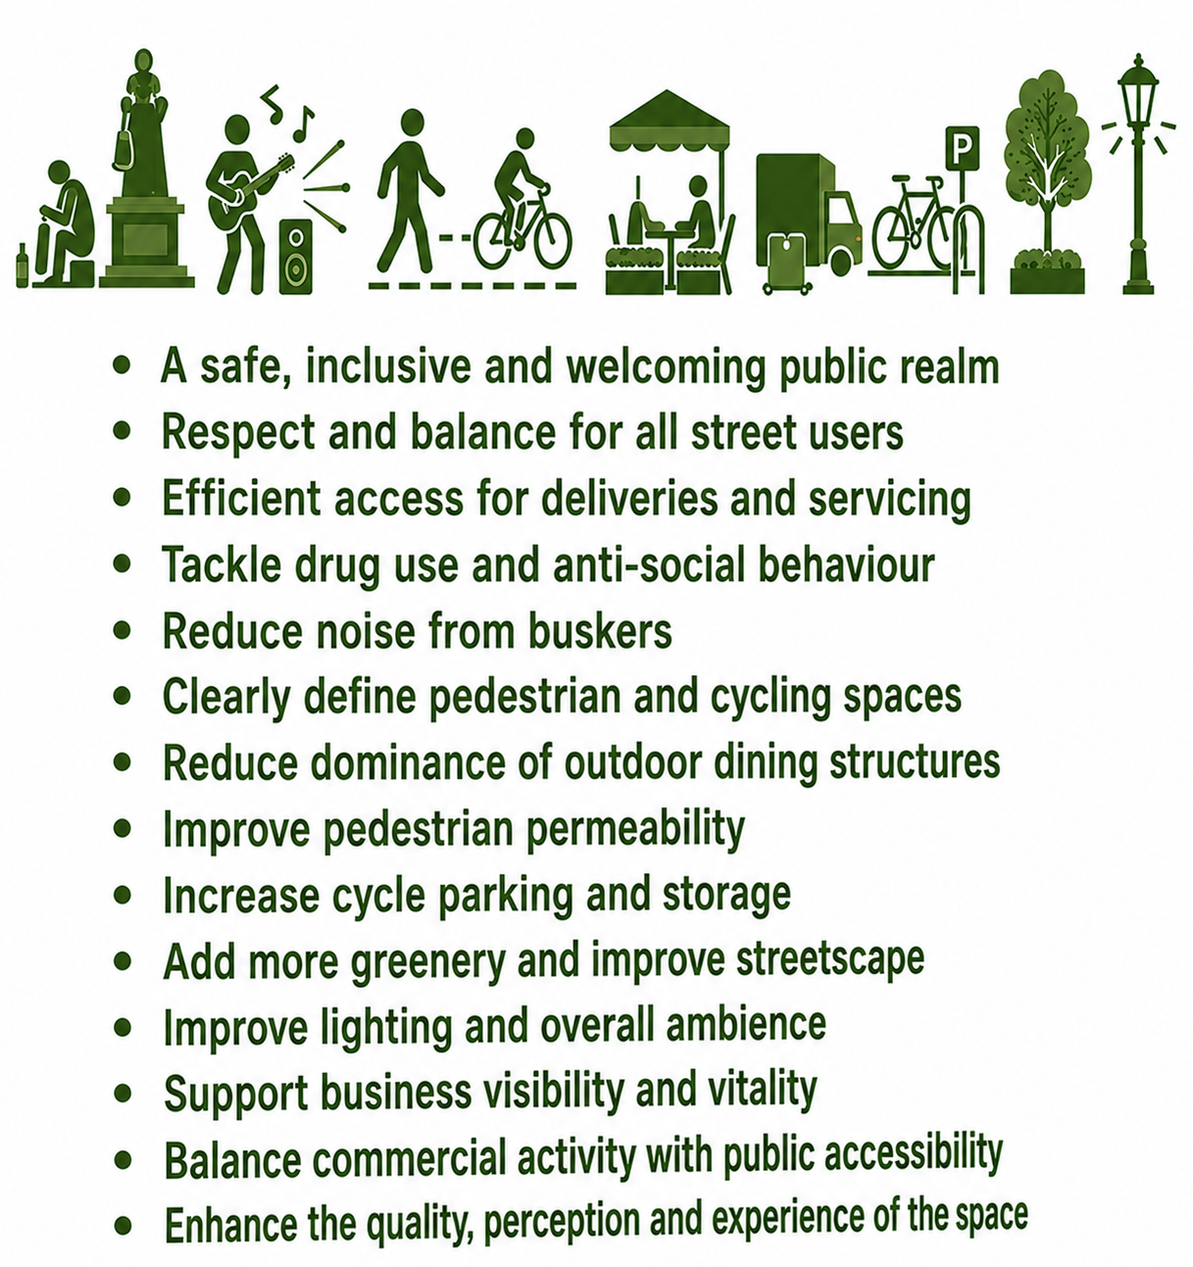

Question 2
How do you use the current space and what are your future needs?
Responses:
Current Use of the Space | Future Needs for the Space
Outdoor dining is used to increase business visibility and attract customers. | Maintain business visibility while accommodating any future changes to the street layout.
Businesses are satisfied with the current street configuration. | Upgrade the paving, lighting, and planting without significantly changing the existing layout.
The current outdoor dining arrangement works well for businesses. | Retain the existing outdoor dining configuration and consider expanding outdoor dining opportunities on Suffolk Street, where conditions are more favourable.
Customers, including those with luggage, regularly use the street to access businesses. | Ensure that future improvements maintain convenient and accessible routes for all users, including those with luggage.
Greenery is appreciated and contributes positively to the street environment. | Increase the amount of greenery through additional planting and, where feasible, more trees.
People use the space to access offices and move through the area. | Provide more opportunities for people to spend time in the space, including outdoor seating for lunch.
The street is used for servicing and deliveries, including cellar access from Suffolk Street. | Ensure future designs continue to accommodate servicing, deliveries, and cellar access without disruption.

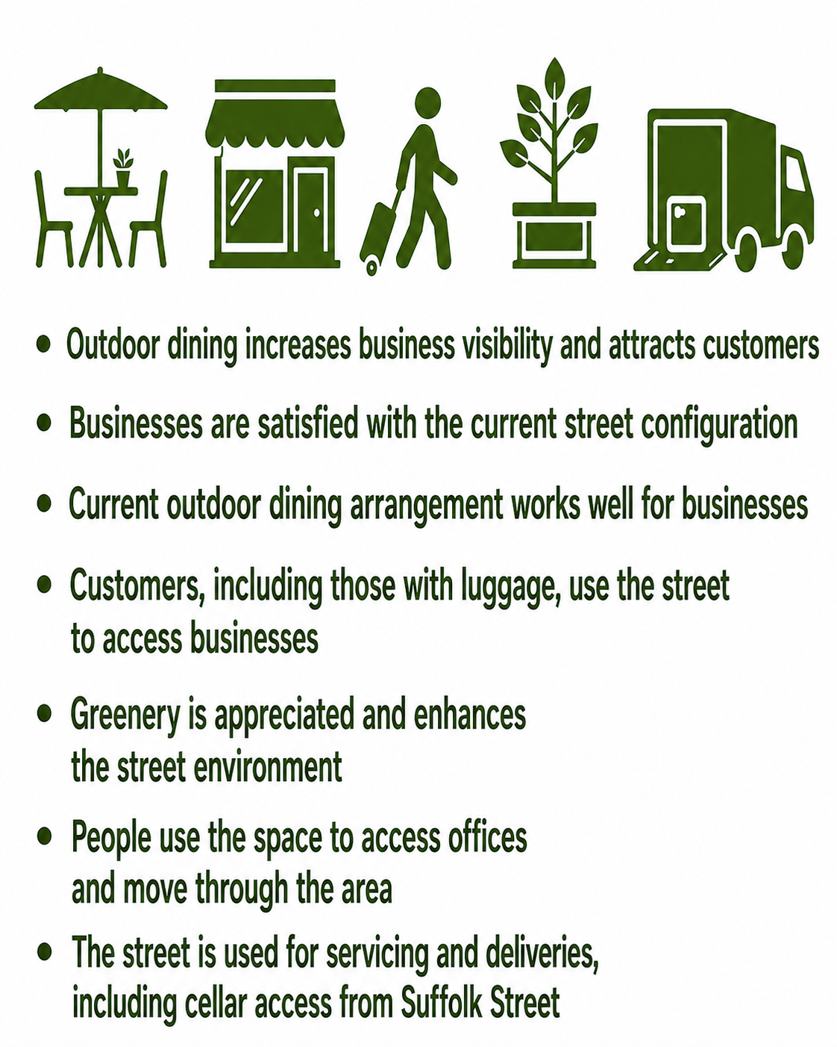

Question 3
What would you like to see in the reimagined space?
Responses:
Theme | Stakeholder Suggestions
Greening and Public Realm Improvements | - Increase the number of trees and planting within the street.
Greening and Public Realm Improvements | - Introduce more elements that enhance the quality and attractiveness of the public realm.
Greening and Public Realm Improvements | - Feature lighting to improve the character and ambience of the space.
Public Seating and Social Spaces | - Provide more public seating opportunities.
Public Seating and Social Spaces | - Existing informal seating areas, such as the ledge in front of the SuperValu, are well used and demonstrate a demand for seating.
Public Seating and Social Spaces | - Consider innovative seating solutions, such as dome/bubble-style seating inspired by places like Camden Market.
Public Seating and Social Spaces | - Introduce street amenities that encourage people to dwell and spend time in the space.
Cycling Infrastructure and Active Travel | - Provide dedicated cycle lanes to improve safety and clarity for cyclists and pedestrians.
Cycling Infrastructure and Active Travel | - Improve pedestrian and cycle coordination, as the current arrangement creates uncertainty over whether some areas are pedestrian or cycling spaces.
Cycling Infrastructure and Active Travel | - Increase cycle parking provision, including secure bike parking lockers.
Pedestrian Movement and Space Management | - Improve pedestrian movement and reduce congestion on footpaths.
Pedestrian Movement and Space Management | - Reconsider the balance between public space and privately occupied areas, particularly outdoor dining structures.
Pedestrian Movement and Space Management | - Break up areas currently dominated by private structures to improve permeability and accessibility.
Noise Management and Street Activity | - Reduce the impact of busker noise, as current sound levels can be disruptive.
Noise Management and Street Activity | - Explore acoustic management measures or designated approaches to reduce noise interference while maintaining street activity.
Events and Flexible Use of Space | - Consider the Suffolk Street and Grafton Street junction as a potential event space.
Events and Flexible Use of Space | - Create a flexible area that can accommodate temporary activities and community events.
Infrastructure and Utilities | - Improve underlying infrastructure, including power supply and utility services.
Infrastructure and Utilities | - Ensure reliable services such as water supply and internet connectivity.
Infrastructure and Utilities | - Provide infrastructure to support future street uses and activities, such as food-related installations or street amenities (e.g., oven/food facilities).

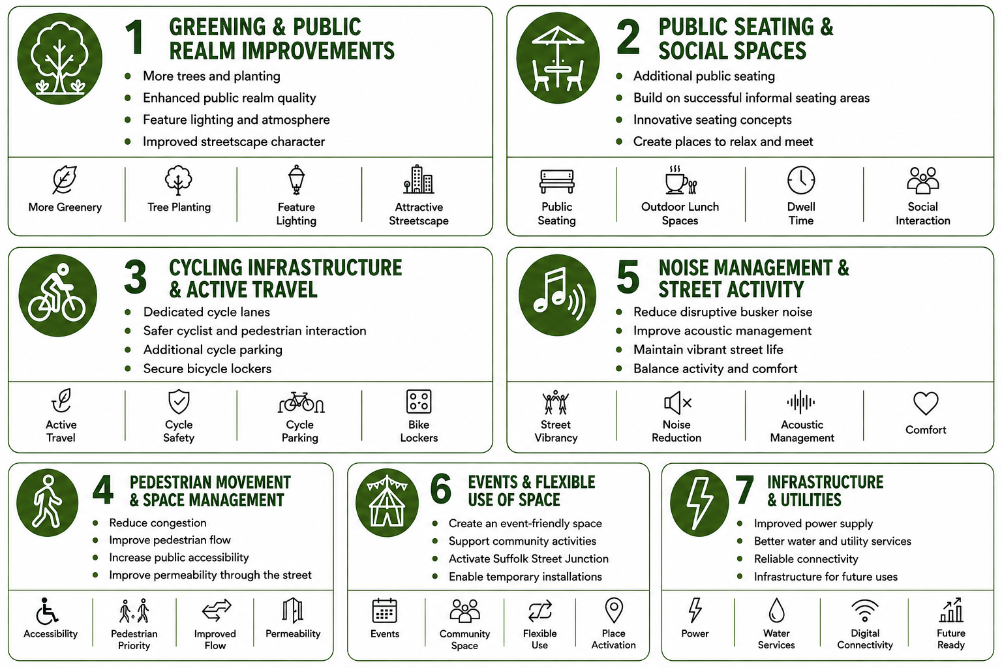

The Information Session demonstrated strong support for investment in Suffolk Street. Businesses welcomed proposals to improve the public realm while maintaining the successful elements of the existing street environment.
The most frequently identified priorities included:
- Retaining successful outdoor dining
- Increasing planting and tree cover
- Improving public seating
- Addressing anti-social behaviour
- Improving pedestrian and cycling movement
- Enhancing lighting
- Maintaining access and servicing arrangements
4) Engagement with Public
4.1. Online Survey on ‘Engage’
As part of the pre-design engagement for the Suffolk Street Public Realm Improvement Project, Dublin City Council (DCC) sought to gather feedback from the wider public through the ‘Engage.ie’ consultation platform. The consultation aimed to understand how people currently use Suffolk Street, identify positive aspects of the existing public realm, and gather views on areas where improvements could be made. The feedback received will help inform the development of the public realm proposals and identify key priorities for the project.

4.2. Survey Responses
For the Suffolk Street Public Realm Improvement Project, the online consultation received 103 responses from participants. The consultation attracted 480 visitors, with a 21.5% participation rate. A total of 103 surveys were submitted, with a 90.4% completion rate, indicating a strong level of engagement from those who participated. Of the 103 responses received, 97 respondents (94.2%) provided feedback in a personal capacity. 2 respondents (1.9%) responded in a professional capacity, while 1 respondent (1.0%) responded on behalf of a group or organisation. A further 1 respondent (1.0%) identified as a local business owner, delivery driver or waste service provider, with 2 respondents (1.9%) selecting ‘Other’. No responses were received from elected representatives.
Of the 103 respondents, 100 provided information on their age group. The largest proportion of respondents were aged 31–45 years (62 respondents), followed by those aged 46–60 years (19 respondents) and 18–30 years (15 respondents). A further 4 respondents were over 60 years, while 3 respondents did not provide an age group. No responses were received from respondents under 18 years of age.

Figure 4.1: Age Distribution of Online Survey Respondents (n=103)
The following chart shows that majority of the respondents are from Dublin City and County:
Figure 4.2: Results of the question ‘Where are you from?’.

As part of the survey, respondents were asked about their travel habits around the project area, for what purpose they visit or use the project area and the frequency of their visits. As shown in Figure 4-3, walking was chosen as the most prevalent mode of transport they normally use to travel to or through the project area.

Figure 4.3: Results of the question 'How do you normally travel to or through the Suffolk Street area?’
According to the survey results, majority of the respondents said they visit the Suffolk Street area on weekend afternoons, as displayed in the following figure:

Figure 4.4: Results of the question ‘How often do you visit the Suffolk Street area?’.
Respondents were asked how frequently they visit the Suffolk Street project area. Weekly visits were the most common response, with 42 respondents, followed by monthly visits (35 respondents) and daily visits (22 respondents). A further 6 respondents reported visiting the area 2–3 times a year, while no respondents selected yearly or less frequently or never.

Figure 4.5 Results of the question ‘When do you visit the Suffolk Street area?’
The survey sought to gather information from respondents on their typical use of the Suffolk Street area, providing them with a list of activities from which they could choose more than one. Options included shopping, socialising, recreation, commuting, work, attending events, tourism and other activities. As shown in the following figure, shopping came out on top as the most common use of the Suffolk Street area among respondents, with 71.8% of votes selecting this activity. Socialising and recreation were the next most common activities, each receiving 64% of votes.

Figure 4.6: Results of the question ‘For what purpose do you visit or use Suffolk Street?’.
The consultation sought to ascertain the challenges of most concern to the public when visiting or using the Suffolk Street area at present. Of the 13 options included as part of the survey, visual clutter appeared as the issue of greatest concern to respondents, with 70 respondents (68.0%) selecting this option, as shown in the figure below. This was followed by a lack of seating, with 58 respondents (56.3%), and a lack of green spaces, with 53 respondents (51.5%). Inadequate cycling infrastructure was also identified as a significant concern, with 50 respondents (48.5%) selecting this option. Other challenges identified by respondents included a lack of public amenities (38.8%), limited pedestrian space (35.0%), accessibility issues (18.4%), traffic congestion (18.4%), safety issues (17.5%), noise (13.6%) and air pollution (10.7%).

Figure 4.7: Results of the question ‘What challenges do you currently face when visiting Suffolk Street?’

As part of the consultation, respondents were asked for their thoughts on the amenities and characteristics found in the project space as it currently stands. The results show that the project area’s architecture was the most favourable characteristic amongst respondents, as shown in the following figure:

Figure 4.8: Results of the question ‘What do you like about the existing Suffolk Street space?’
Respondents were asked about their thoughts on what they would like to see in the area and how it could be enhanced in the future. As shown in Figure 4.8, space for pedestrians and reduced traffic and pollution were tied for top place.

Figure 4.9: Results of the question ‘What would you like to see on Suffolk Street in the future?’
The public responses demonstrated strong support for improving Suffolk Street into a high-quality, permanent pedestrian-priority public space, while emphasising the need to balance the needs of pedestrians, cyclists, businesses, outdoor dining and servicing.
A key theme was the need for a coherent and attractive public realm that reflects the historic character of Suffolk Street and connects visually with Grafton Street and the proposed College Green scheme. Respondents supported high-quality, durable paving and materials, coordinated street furniture, heritage-appropriate lighting and a consistent design approach. There was particular criticism of the existing yellow surfacing and the amount of visual clutter, with calls to rationalise signage, bollards, planters, barriers and other street furniture.
Pedestrian priority and accessibility were strongly emphasised. Respondents called for permanent removal of traffic, wider and uninterrupted pedestrian areas, and a continuous level surface with reduced or removed kerbs to improve accessibility, particularly for wheelchair users. The street should provide sufficient space for pedestrians without obstruction from outdoor dining, vehicles or other infrastructure.
Cycling provision was another significant theme. While respondents generally supported maintaining cycling permeability, many highlighted conflicts between cyclists and pedestrians and called for clearly defined or segregated cycle facilities. Suggestions included contrasting surfacing, visual cues and narrow cycle routes designed to reduce cycling speeds. Others felt that cycling could instead be accommodated through alternative routes via College Green, Nassau Street or Grafton Street. Better integration of cycling routes and crossings at the Grafton Street and Nassau Street junctions was also requested.
There was considerable support for retaining outdoor dining, which respondents viewed as an important contributor to the street's vibrancy, atmosphere and economic activity. However, respondents also called for better regulation and a coherent design standard for private dining areas, including consistent furniture and umbrellas, reduced branding, and fewer barriers or glass screens. Outdoor dining should be located and managed so that it does not obstruct the main pedestrian route. The importance of protecting existing businesses while improving the public realm was also highlighted.
Respondents frequently requested more public seating and amenities so that Suffolk Street can function as a place to stay and socialise rather than simply a route between Grafton Street and College Green. Suggestions included public benches, sheltered seating, public toilets, drinking fountains, bins, cycle parking and opportunities for cultural or community activities. Some respondents suggested weather-protected spaces to allow the street to be used comfortably throughout the year.
Greening and landscaping were widely supported, although some respondents recognised the limitations created by the narrow street. Suggestions included street trees, additional planting, native and drought-resistant species, attractive landscaping and Sustainable Urban Drainage Systems (SuDS) where feasible. Landscaping was also suggested as a means of helping to define cycling and pedestrian areas without creating additional clutter.
The junctions and connections with surrounding streets were identified as areas requiring particular attention. Respondents called for clearer pedestrian and cycling movements at Grafton Street, Nassau Street and Church Lane, improved crossings, better integration with the Luas and surrounding cycling network, and a more seamless connection with Grafton Street and College Green. Suffolk Street was viewed as part of a wider network of city-centre public spaces and should therefore be designed in conjunction with surrounding schemes.
Vehicle and delivery management was another recurring issue. Respondents generally supported restricting general vehicle access while maintaining controlled access for deliveries and emergency services. Timed deliveries, electronic bollards or barriers and stronger enforcement were suggested. Delivery vehicles obstructing pedestrian and cycling areas were identified as a current problem.
Respondents also highlighted safety, cleanliness and maintenance, including concerns regarding antisocial behaviour, litter, poorly maintained outdoor dining areas and fast-moving delivery cyclists. Improved lighting, CCTV, policing, maintenance and enforcement were suggested to make the street safer and more welcoming.
Some respondents highlighted the importance of St Andrew's Church and the Molly Malone statue as part of the area's heritage and identity. Suggestions included improving the setting around the statue, reducing unattractive landscaping and exploring opportunities to integrate the church into the public realm as a cultural or community asset.
Overall, the consultation feedback supports a permanent, cohesive and high-quality public realm for Suffolk Street, with priorities focused on pedestrian accessibility, high-quality materials, reduced clutter, appropriate cycling provision, well-managed outdoor dining, public seating and amenities, greening, improved junctions and connections, and better management of vehicles and deliveries. At the same time, respondents stressed that the scheme should build on the positive changes introduced through the existing outdoor dining and pedestrian measures while protecting the vitality and businesses of the street.
5) Next Steps
All feedback, comments and concerns received during the pre-design consultation process, including the Dublin DPO Consultation, the Information Session with local businesses and residents, and public engagement through Engage.ie, will be considered by the DCC Project Team in the development of the preliminary design for the Suffolk Street Public Realm Improvement Scheme.
The feedback received from the three consultation exercises provides valuable insight into the existing experience of Suffolk Street, including issues relating to accessibility, pedestrian movement, interaction between pedestrians and cyclists, public space, seating and greening, servicing and deliveries, traffic and parking, and the overall character and vitality of the area. These comments will be reviewed alongside the objectives of the scheme and the technical and operational requirements of the site.
The consultation feedback will help inform the development and evaluation of the emerging design, with particular consideration given to prioritising pedestrian movement, improving accessibility and inclusive mobility, supporting active travel, increasing greening and public seating, and creating a high-quality public realm that supports the cultural, social and economic vitality of Suffolk Street. The design development will also take account of existing infrastructure requirements, including drainage and utility upgrades, while ensuring that essential access, including emergency services and morning deliveries, can be maintained.
As the project progresses through the next stage of design development, the DCC Project Team will continue to engage with Dublin DPO, local businesses and residents, the wider public, and relevant DCC departments and stakeholders. Further engagement will be undertaken, where appropriate, to review and refine the emerging proposals and to ensure that the feedback received during Pre-design stage is appropriately considered in the ongoing development of the Suffolk Street Public Realm Improvement Scheme.

